Insert your name, centre number and candidate number into the header above.
Save this evidence document as evidence_ followed by your centre number_ candidate number. For example: evidence_ zz999_9999.doc
Screenshots or program listings must be copied into appropriate cells in the following tables.
Examiners must be able to read the contents including any screenshots without the use of a magnifying glass. Answers that are not readable or missing will not be awarded any marks.
Save this evidence document at regular intervals, for example, every 10 minutes.
Question 1
Part 1(a)(i)
class EventItem():
def __init__(self,pName,pType,pDifficulty):
self.__EventName= pName #string
self.__Type =pType #string
self.__Difficulty= pDifficulty #integer

Part 1(a)(ii)
def GetName(self):
return self.__EventName
def GetEventType(self):
return self.__Type
def GetDifficulty(self):
return self.__Difficulty

Part 1(b)(i)
Group= [] #type Event, 5 spaces

Part 1(b)(ii)
Group.append(EventItem("Bridge","jump",3))
Group.append(EventItem("Water wade","swim",4))
Group.append(EventItem("100 mile run","run",5))
Group.append(EventItem("Gridlock","drive",2))
Group.append(EventItem("Wall on wall","jump",4))

Part 1(c)
class Character():
def __init__(self,pName,pJump,pSwim,pRun,pDrive):
self.__CharacterName= pName #string
self.__Jump= pJump #integer chance of success
self.__Swim= pSwim #integer chance of success
self.__Run= pRun #integer chance of success
self.__Drive= pDrive #integer chance of success
def GetName(self):
return self.__CharacterName #STRING

Part 1(d)
def CalculateScore(self,Type,Difficulty):
if Type == "jump":
Chance= self.__Jump
elif Type == "swim":
Chance= self.__Swim
elif Type == "run":
Chance= self.__Run
else:
Chance= self.__Drive
if Chance >= Difficulty:
return 100
else:
Difference= Difficulty - Chance
if Difference == 1:
return 80
elif Difference == 2:
return 60
elif Difference == 3:
return 40
elif Difference == 4:
return 20
else:
return 0

Part 1(e)(i)
P1= Character("Tarz",5,3,5,1)
P2= Character("Geni",2,2,3,4)

Part 1(e)(ii)
P1Points= 0
P2Points= 0
for x in range(0,5):
P1EventScore= P1.CalculateScore(Group[x].GetEventType(),Group[x].GetDifficulty())
P2EventScore= P2.CalculateScore(Group[x].GetEventType(),Group[x].GetDifficulty())
if P1EventScore>P2EventScore:
P1Points= P1Points+1
print(P1.GetName(), "you win this event")
elif P2EventScore>P1EventScore:
P2Points= P2Points+1
print(P2.GetName(), "you win this event")
else:
print("This event is a draw")

if P1Points>P2Points:
print(P1.GetName(), "you have won with", P1Points)
elif P2Points>P1Points:
print(P2.GetName(), "you have won with", P2Points)
else:
print("It's a draw")

Part 1(e)(iii)
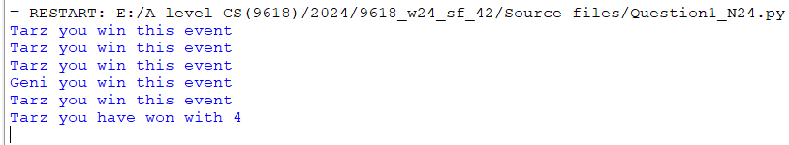

Question 2
Part 2(a)
class Queue:
def __init__(self):
self.QueueArray=[]
self.HeadPointer=0 #integer
self.TailPointer=0 #integer
for x in range(0,100):
self.QueueArray.append(-1)

Part 2(b)
class Queue:
def __init__(self):
self.QueueArray=[]
for x in range(0,100):
self.QueueArray.append(-1)
self.HeadPointer=-1 #integer
self.TailPointer=0 #integer

TheQueue= Queue()

Part 2(c)
def Enqueue(AQueue, TheData):
if AQueue.HeadPointer == -1:
AQueue.QueueArray[AQueue.TailPointer] = TheData
AQueue.HeadPointer = 0
AQueue.TailPointer += 1
return 1
elif AQueue.TailPointer >99:
return -1
else:
AQueue.QueueArray[AQueue.TailPointer] = TheData
AQueue.TailPointer = AQueue.TailPointer + 1
return 1

Part 2(d)
def ReturnAllData(TheQueue):
Temp = ""
for X in range(TheQueue.HeadPointer,TheQueue.TailPointer):
Temp= Temp+ str(TheQueue.QueueArray[X])+ " "
return Temp

Part 2(e)(i)
for x in range(0,10):
Continue = True
while (Continue == True):
DataInput= int(input("Enter an integer that is 0 or more"))
if DataInput > -1:
Continue = False
ReturnValue= Enqueue(TheQueue, DataInput)
if (ReturnValue == -1):
print("Queue full")
else:
print("Item inserted")

print(ReturnAllData(TheQueue))

Part 2(e)(ii)
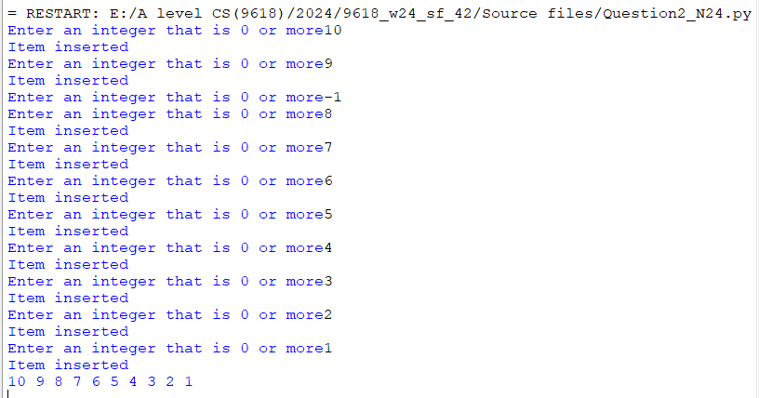

Part 2(f)
def Dequeue(AQueue):
if AQueue.HeadPointer == 100 or AQueue.HeadPointer == -1 or AQueue.HeadPointer == AQueue.TailPointer:
return -1
else:
Temp= AQueue.QueueArray[AQueue.HeadPointer]
AQueue.HeadPointer= AQueue.HeadPointer + 1
return Temp

Part 2(g)(i)
ReturnValue= Dequeue(TheQueue)
if ReturnValue == -1:
print("Queue empty")
else:
print(ReturnValue, "is returned")
ReturnValue= Dequeue(TheQueue)
if ReturnValue == -1:
print("Queue empty")
else:
print(ReturnValue, "is returned")
print(ReturnAllData(TheQueue))

Part 2(g)(ii)
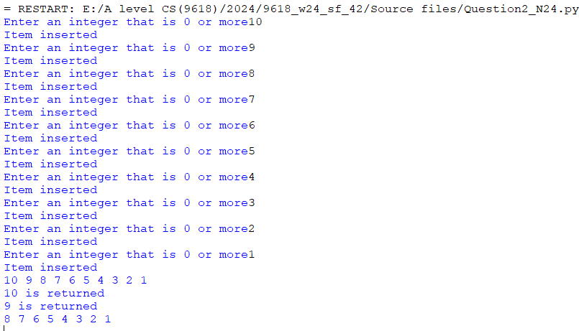

Question 3
Part 3(a)
HighScores=[] #String, 7 x 3
HighScores=[[''for x in range(3)]for y in range(7)]

Part 3(b)
def ReadData():
Temp=[]
HighScores=[]
try:
File=open("HighScoreTable.txt")
Temp= File.read().split("\n")
File.close()
except:
print("No file found")
NumberRecords= len(Temp)-1
Counter=0
while Counter<NumberRecords:
HighScores.append([Temp[Counter],Temp[Counter+1],Temp[Counter+2]])
Counter= Counter+3
return HighScores

Part 3(c)
def OutputHighScores(HighScores):
for x in range(0,len(HighScores)):
print(HighScores[x][0], "reached level", HighScores[x][1], "with a score of", HighScores[x][2])

Part 3(d)
def SortScores(HighScores):
Counter= 0
ArrayLength=len(HighScores)
for x in range(ArrayLength-1):
for y in range(0,ArrayLength-x-1):
if int(HighScores[y][1])<int(HighScores[y+1][1]):
HighScores[y],HighScores[y+1]=HighScores[y+1],HighScores[y]
elif int(HighScores[y][1]) == int(HighScores[y+1][1]):
if int(HighScores[y][2])<int(HighScores[y+1][2]):
HighScores[y],HighScores[y+1]=HighScores[y+1],HighScores[y]
return HighScores

Part 3(e)(i)
HighScores=[]
HighScores= ReadData()
print("Before")
OutputHighScores(HighScores)
HighScores= SortScores(HighScores)
print("After")
OutputHighScores(HighScores)

Part 3(e)(ii)
